LAPORAN KUIS 2

PRAKTIKUM DASAR PEMROGRAMAN

Oleh:

MOCHAMMAD SYAIFUDDIN ZUHRI NIM. 1941720013



PROGRAM STUDI TEKNIK INFORMATIKA

JURUSAN TEKNOLOGI INFORMASI

POLITEKNIK NEGERI MALANG

19 NOVEMBER 2019

**TIPE SOAL A**

1. **FLOWCHART**

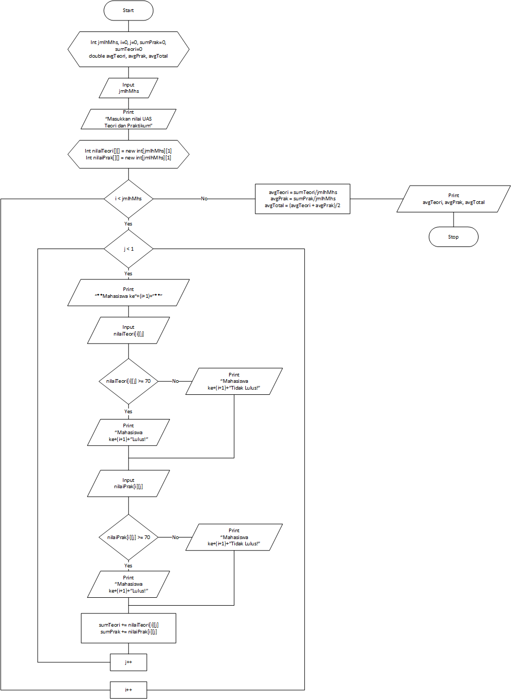

1. **SOURCE CODE**

|  |  |
| --- | --- |
| 1 | package Kuis2Daspro; |
| 2 |  |
| 3 | import java.util.Scanner; |
| 4 |  |
| 5 | public class soal1 { |
| 6 | public static void main(String[] args) { |
| 7 |  |
| 8 | System.out.println("==============================================="); |
| 9 | System.out.println("\tKUIS 2 PRAKTIKUM DASAR PEMROGRAMAN"); |
| 10 | System.out.println("==============================================="); |
| 11 | System.out.println(""); |
| 12 | System.out.println("-----------------------------------------------"); |
| 13 | System.out.println("\t\t PROFIL MAHASISWA"); |
| 14 | System.out.println("-----------------------------------------------"); |
| 15 | System.out.println("Nama\t\t: Mochammad Syaifuddin Zuhri"); |
| 16 | System.out.println("NIM\t\t: 1941720013"); |
| 17 | System.out.println("Kelas\t\t: TI 1E"); |
| 18 | System.out.println(“-----------------------------------------------"); |
| 19 |  |
| 20 | Scanner input = new Scanner(System.in); |
| 21 |  |
| 22 | System.out.println(""); |
| 23 | System.out.print("Masukkan jumlah Mahasiswa : "); |
| 24 | int jmlhMhs = input.nextInt(); |
| 25 | System.out.println(""); |
| 26 |  |
| 27 | System.out.println("---Masukkan nilai UAS Teori dan Praktikum---"); |
| 28 | System.out.println(""); |
| 29 |  |
| 30 | int nilaiPrak[][] = new int[jmlhMhs][1]; |
| 31 | int nilaiTeori[][] = new int[jmlhMhs][1]; |
| 32 | int sumPrak = 0, sumTeori = 0; |
| 33 | double avgPrak, avgTeori, avgTotal; |
| 34 |  |
| 35 | for (int i = 0; i < jmlhMhs; i++) { |
| 36 | for (int j = 0; j < 1; j++) { |
| 37 | System.out.println("** Mahasiswa ke-"+(i+1)+" **"); |
| 38 | System.out.print("Nilai UAS Teori = "); |
| 39 | nilaiTeori[i][j]= input.nextInt(); |
| 40 | if (nilaiTeori[i][j] >= 70){ |
| 41 | System.out.println("Mahasiswa ke-"+(i+1)+" Lulus!"); |
| 42 | } else { |
| 43 | System.out.println("Mahasiswa ke-"+(i+1)+" Tidak Lulus!"); |
| 44 | } |
| 45 |  |
| 46 | System.out.print("Nilai UAS Praktikum = "); |
| 47 | nilaiPrak[i][j] = input.nextInt(); |
| 48 | if (nilaiPrak[i][j] >= 70){ |
| 49 | System.out.println("Mahasiswa ke-"+(i+1)+" Lulus!"); |
| 50 | } else { |
| 51 | System.out.println("Mahasiswa ke-"+(i+1)+" Tidak Lulus!"); |
| 52 | } |
| 53 |  |
| 54 | sumTeori += nilaiTeori[i][j]; |
| 55 | sumPrak += nilaiPrak[i][j]; |
| 56 | } |
| 57 | System.out.println(""); |
| 58 | } |
| 59 |  |
| 60 | avgTeori = sumTeori/jmlhMhs; |
| 61 | avgPrak = sumPrak/jmlhMhs; |
| 62 | avgTotal = (avgTeori+avgPrak)/2; |
| 63 |  |
| 64 | System.out.println("Rata-rata total nilai UAS Teori = "+avgTeori); |
| 65 | System.out.println("Rata-rata total nilai UAS Praktikum = "+avgPrak); |
| 66 | System.out.println("Nilai rata-rata UAS Teori dan Praktikum = "+avgTotal); |
| 67 | System.out.println(""); |
| 68 |  |
| 69 | } |
| 70 | } |

1. **OUTPUT PROGRAM**

